1. Create DATABASE

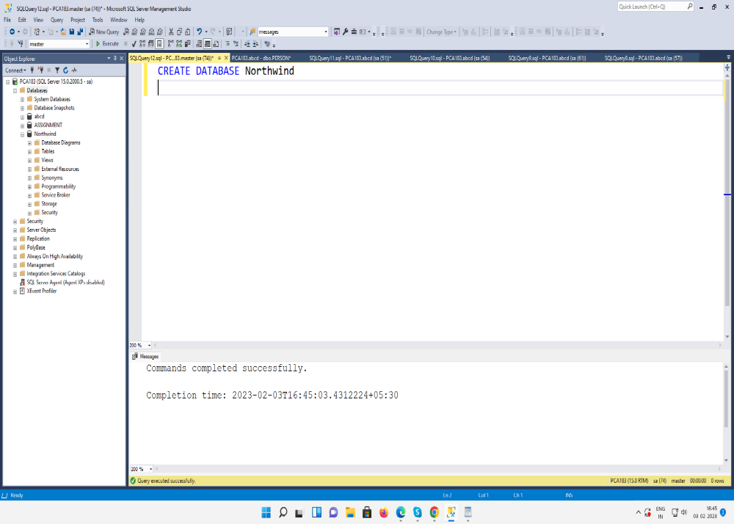

2. Create TABLE
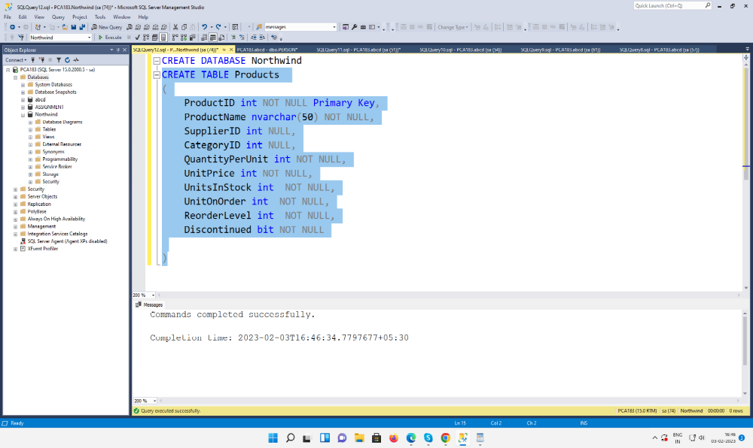

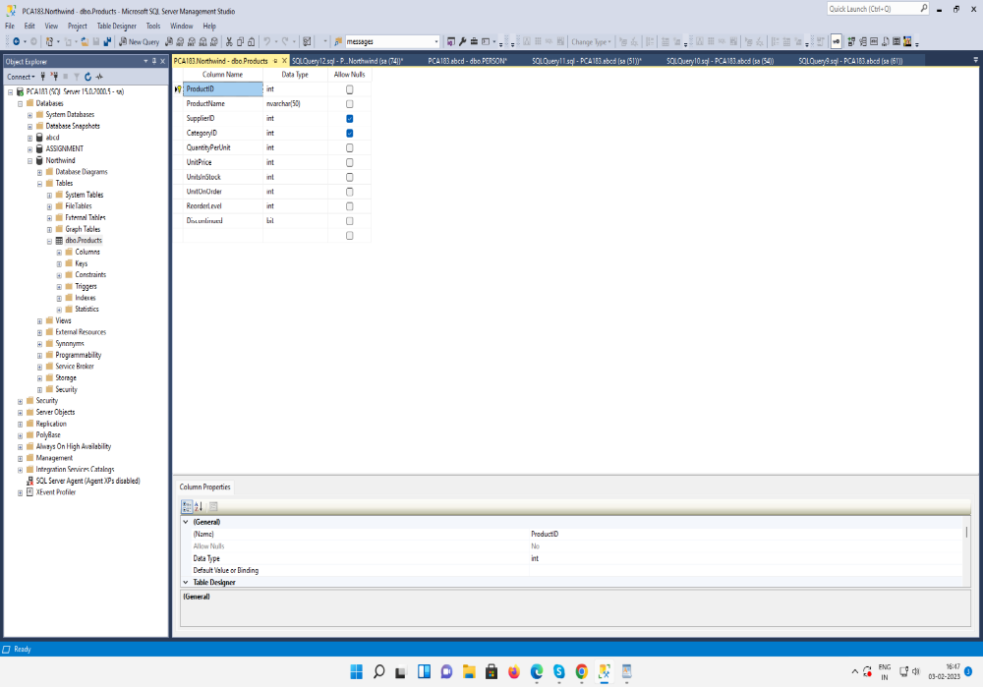

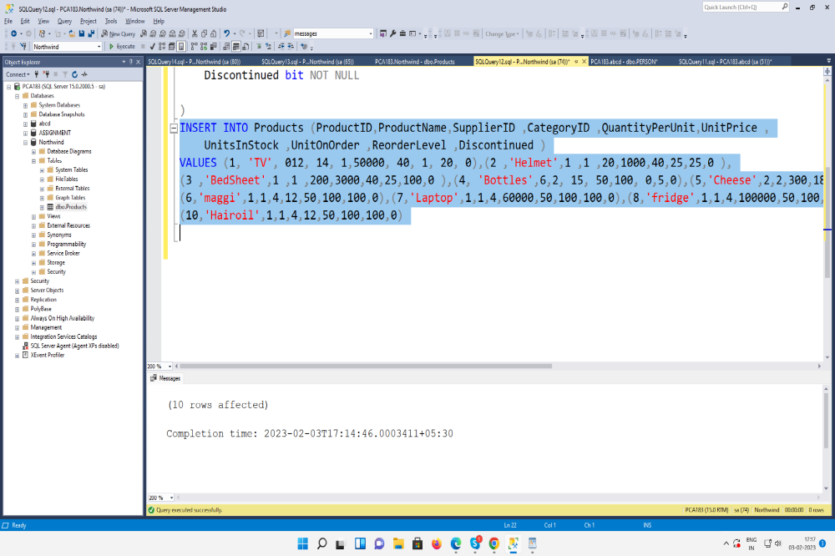

QUERY1
Write a query to get a Product list (id, name, unit price) where current products cost
less than $20.

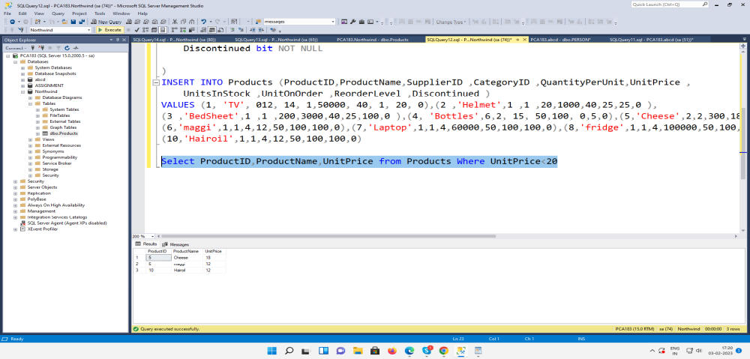

QUERY2
Write a query to get Product list (id, name, unit price) where products cost between
$15 and $25
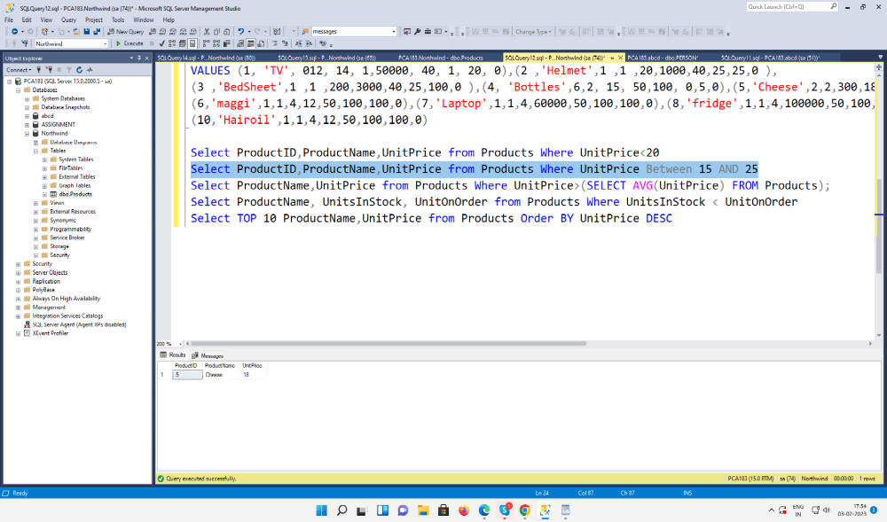

QUERY3
Write a query to get Product list (name, unit price) of above average price.
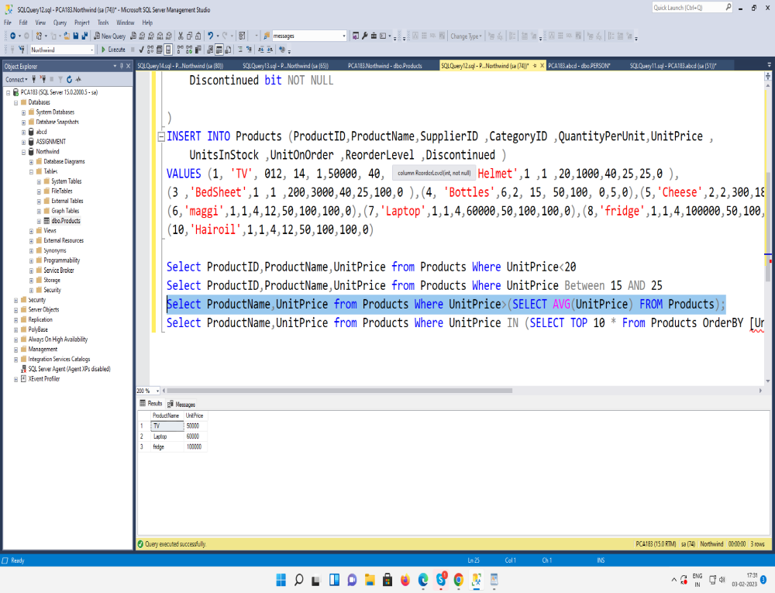

QUERY4
Write a query to get Product list (name, unit price) of ten most expensive products
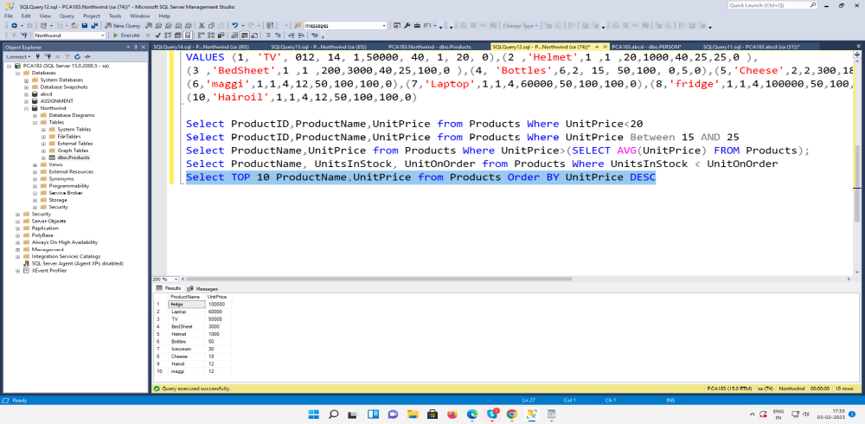
QUERY5
Write a query to count current and discontinued products
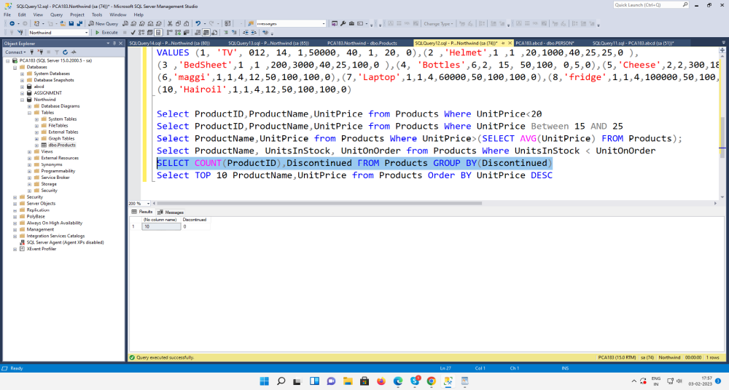

QUERY6
Write a query to get Product list (name, units on order , units in stock) of stock is less
than the quantity on order
